**CHAPTER 6**

**SAMPLE FORMS**

**6.1 Admin Login**

This is the admin login page. The admin can login to the system by given his email and password.

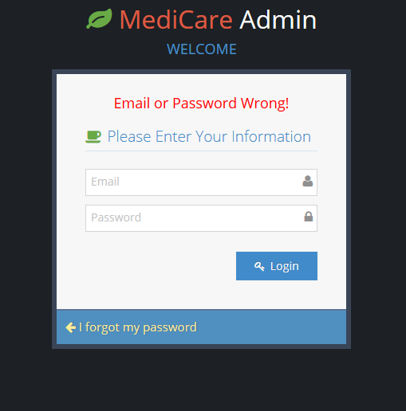

Figure: 6.1 Admin Login

**6.2 Admin Home Page**

This is the admin home page. From here admin can see the total overview of the seller. Admin can see the total number of sellers, New seller according to the current month and see the seller request.

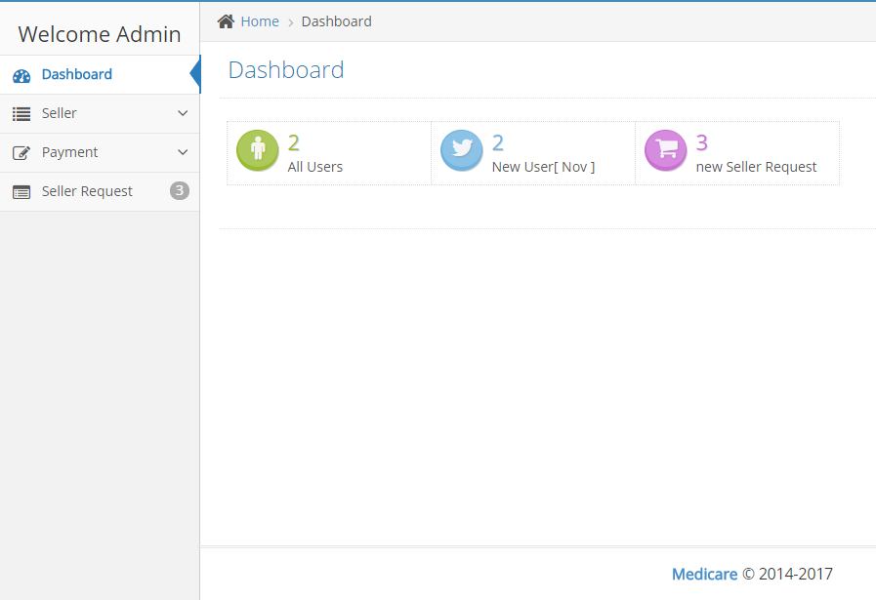

Figure: 6.2 Admin Home Page

**6.2.1 Add Seller**

From the admin home page the admin can add seller by using this form.

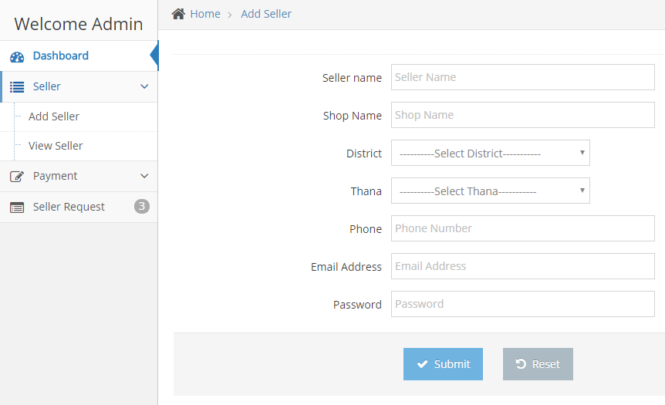

Figure: 6.3 Add Seller

**6.2.2 View Seller Details**

From this page the admin can see the every seller and their details. Admin can also able to suspend or active any seller at any time**.**

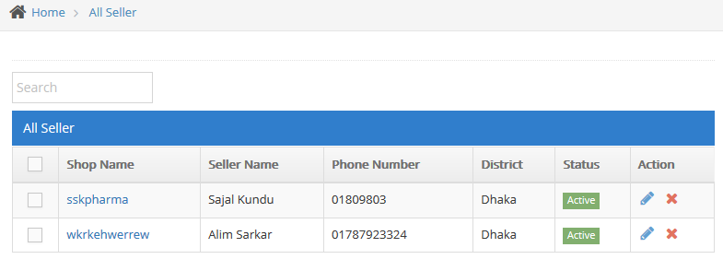

Figure: 6.4 Seller Details

**6.2.3 Payment**

This is the payment page. Admin can see the payment details according to the current month.

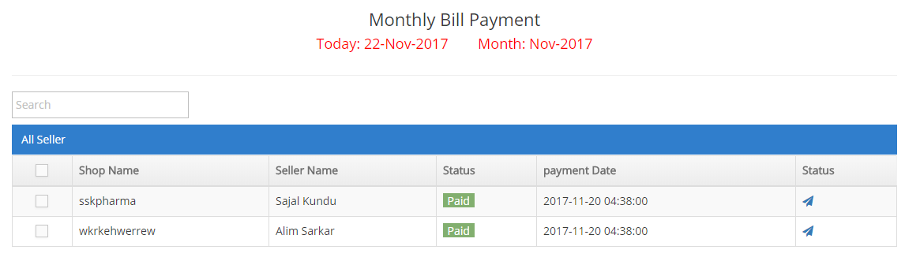Figure: 6.5 Seller Details

**6.2.4 Seller Request**

This is the seller request page. Admin can see the pending seller request from this page who want to become a seller.

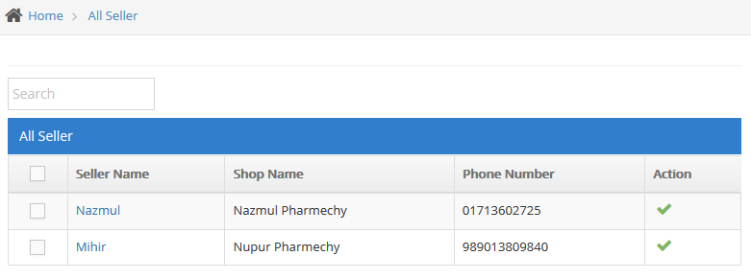

Figure:6.6 Seller Request

**6.3 Seller Login**

This is the seller login page. The seller can login to the system by given his email and password.

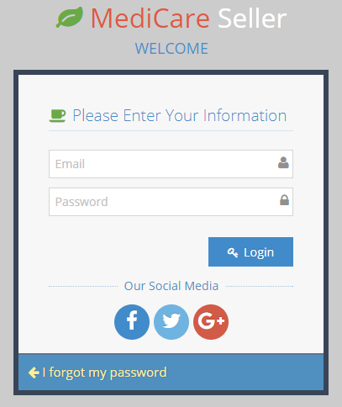

Figure:6.7 Seller Login

**6.3.1 Seller Home page**

This is the seller home page. From this page the seller can do the following task

* Add and view brand.
* Add, remove, purchase and view product.
* Stock product.
* Generate a purchase report.
* Sales product.
* They can do the all kinds of transaction with the admins.
* Seller can view total purchase, total payment, total sale, total due
* Get product notification
* Get bill notification
* See the message

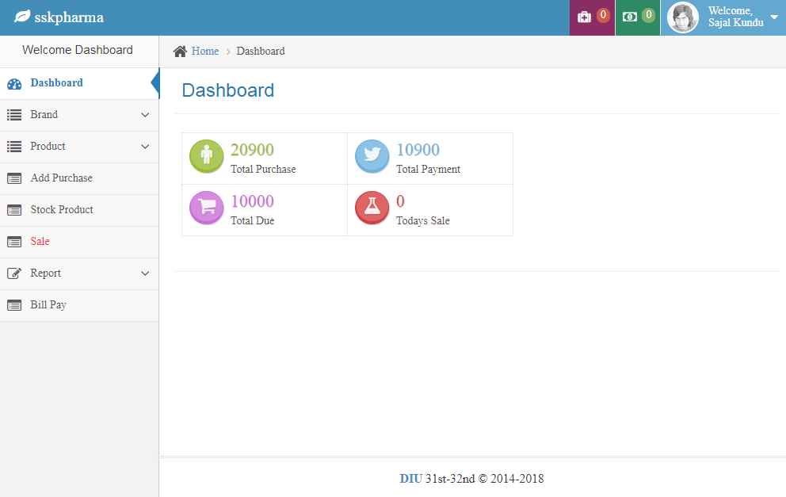

Figure:6.8 Seller Home Page

**6.3.2 Add Brand**

From this page the seller can add brand name, brand description providing their contact number.

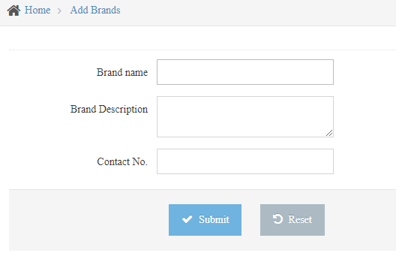

Figure: 6.9 Add Brand

**6.3.3 View Brand Details**

This is the brand section. Sellers can see the brand details from this page.

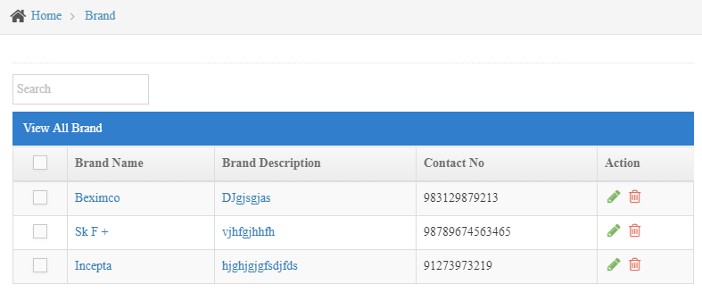 Figure: 6.10 View Brand Details

**6.3.4 Add Product**

Seller can add product from this page by completing the required field of the following form.

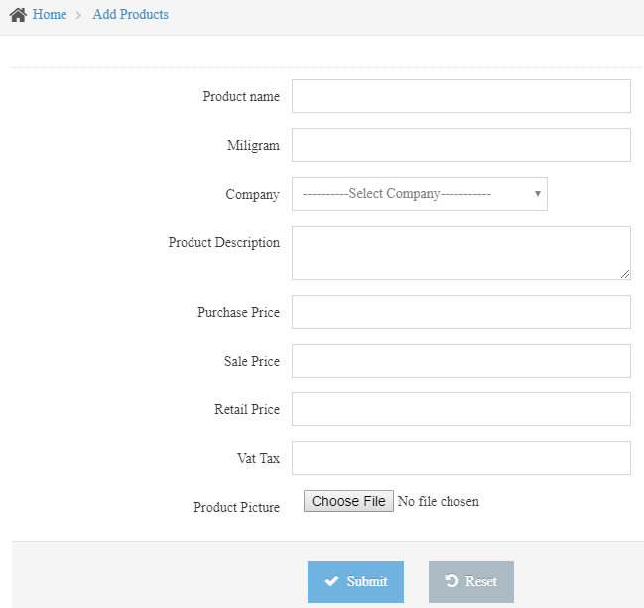

Figure: 6.11 Add Product

**6.3.5 View Product Details**

This is the page where a seller can see the product details, update product details, remove product

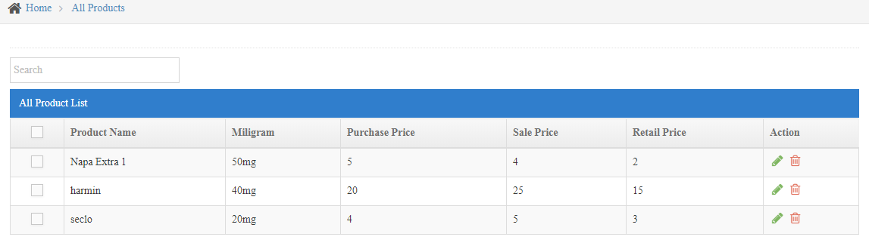

Figure: 6.12 View Product Details

**6.3.6 Stock Product**

Here the seller can see the product quantity, product price, product name, sale price, purchase price etc.

,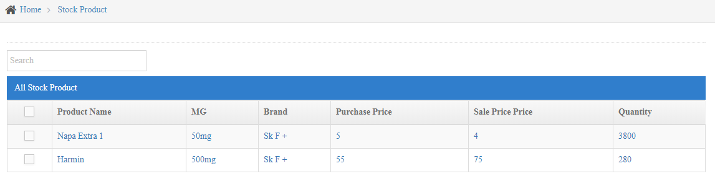

Figure: 6.13 Stock Product

**6.3.7 Invoice**

Seller can sale their product and generate bill with vat from this page

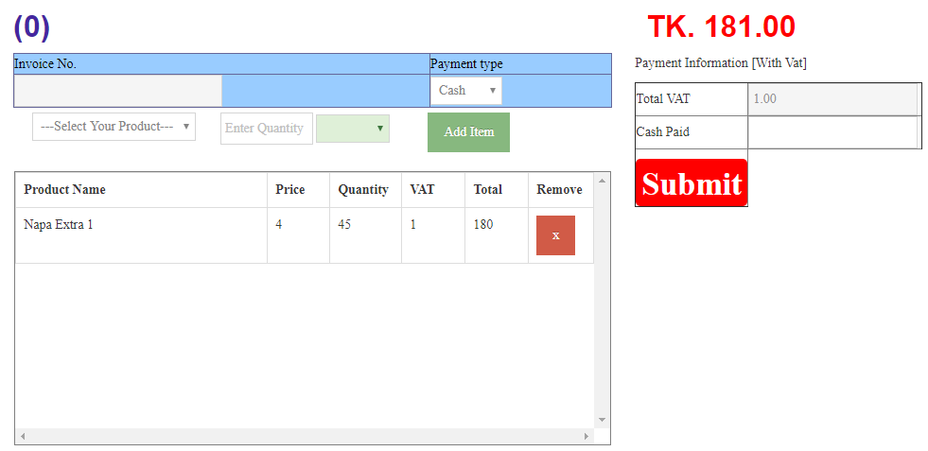

Figure: 6.14 Invoice

**6.3.8 Bill Pay**

In this page seller will send billing information to admin monthly. Seller can pay via Bank Account, Bkash, UCASH, Datuch Bangla Mobile Bankking.

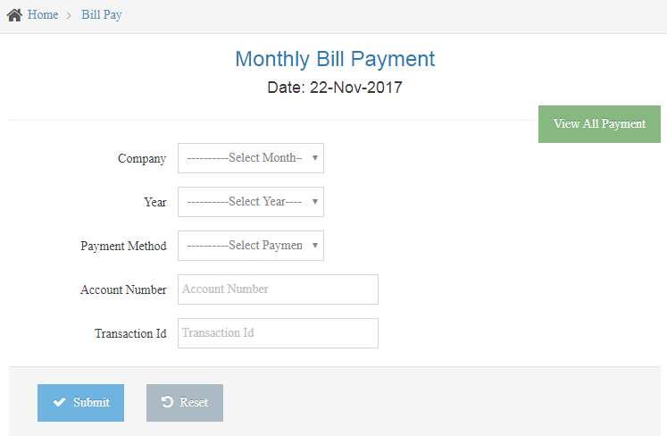

Figure: 6.15 Bill Pay

**6.4 Madicare Home Page**  
This is the madicare homepage or the front page of the system. Upper part of the page contains contact information of the system in left side and social media links in the right side. An user can search product from here by district name, police station name and the medicine name. If the product is available then it will be shown here otherwise no information will be seen. If the product that user searching is available in more than one shop under same police station of the district that will also be seen by search.

Then user can choose the shop that is nearest from his place by clicking the product. When user clicks the product details, it will show the details (price, shop location, cell num of the seller).And also can see the quantity of the product by search.In lower part of this page contains about the system, contact info and navigations. And the lower right side also got social links for the system.

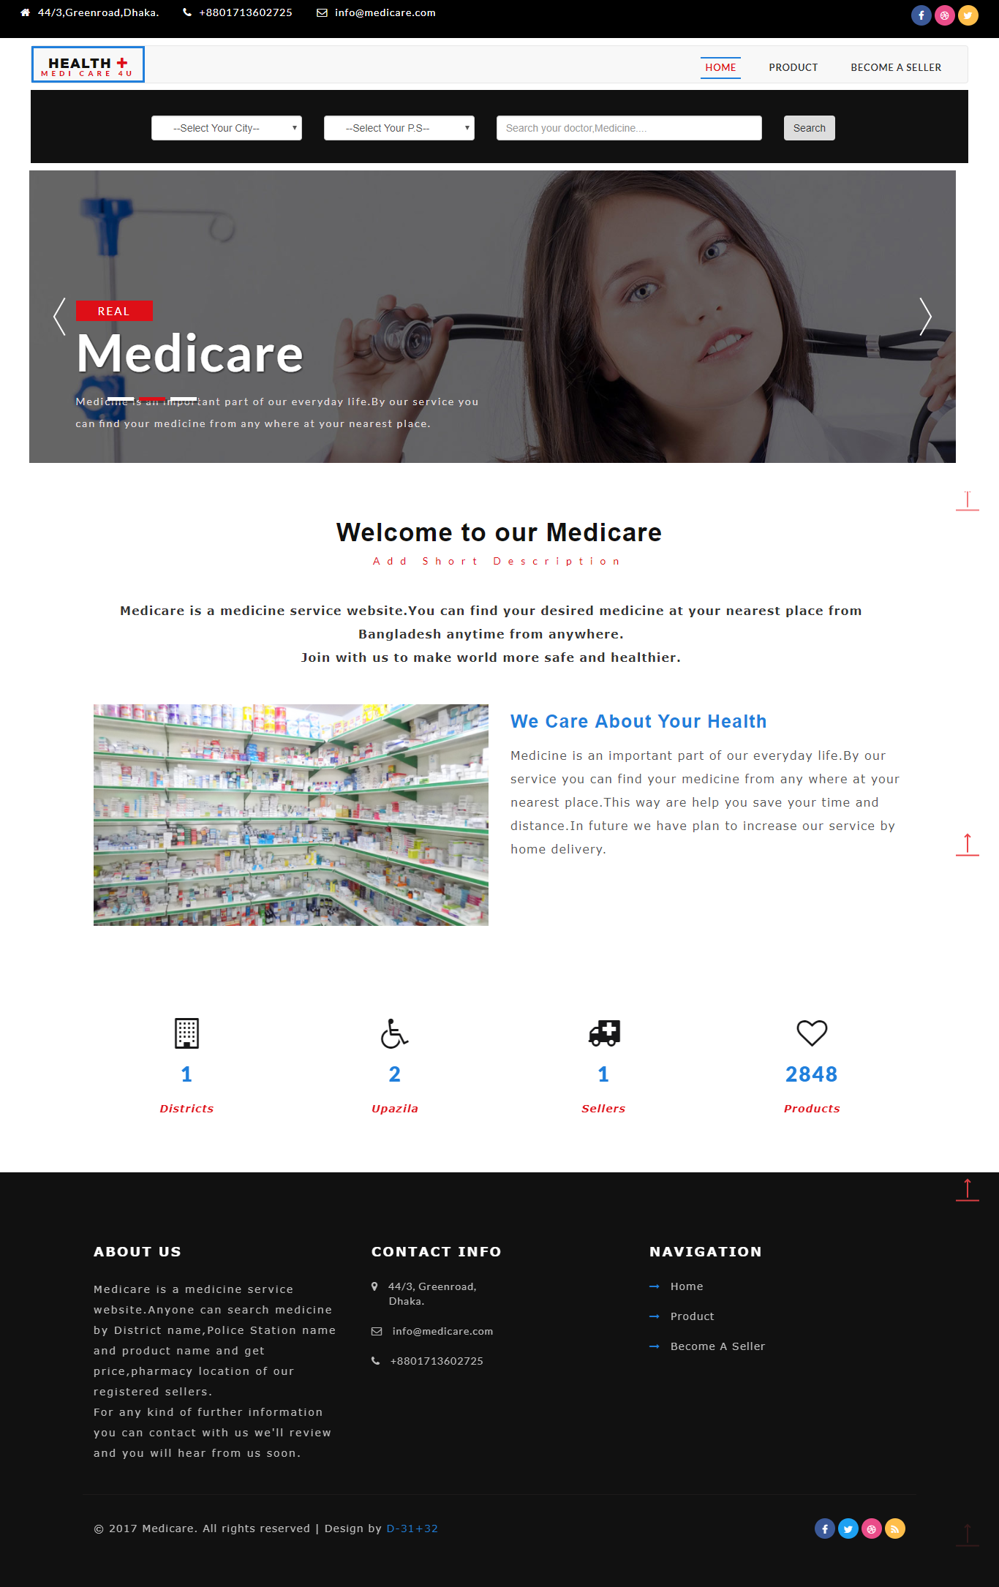

Figure: 6.16 Madicare Home Page

**6.5 Medicare Product Page**

This page contains the all product information that all the seller shops have. By clicking any product or product image, anyone can see all the details about the products ( Brand name , product quantity, product description, shop location, seller cell num etc)

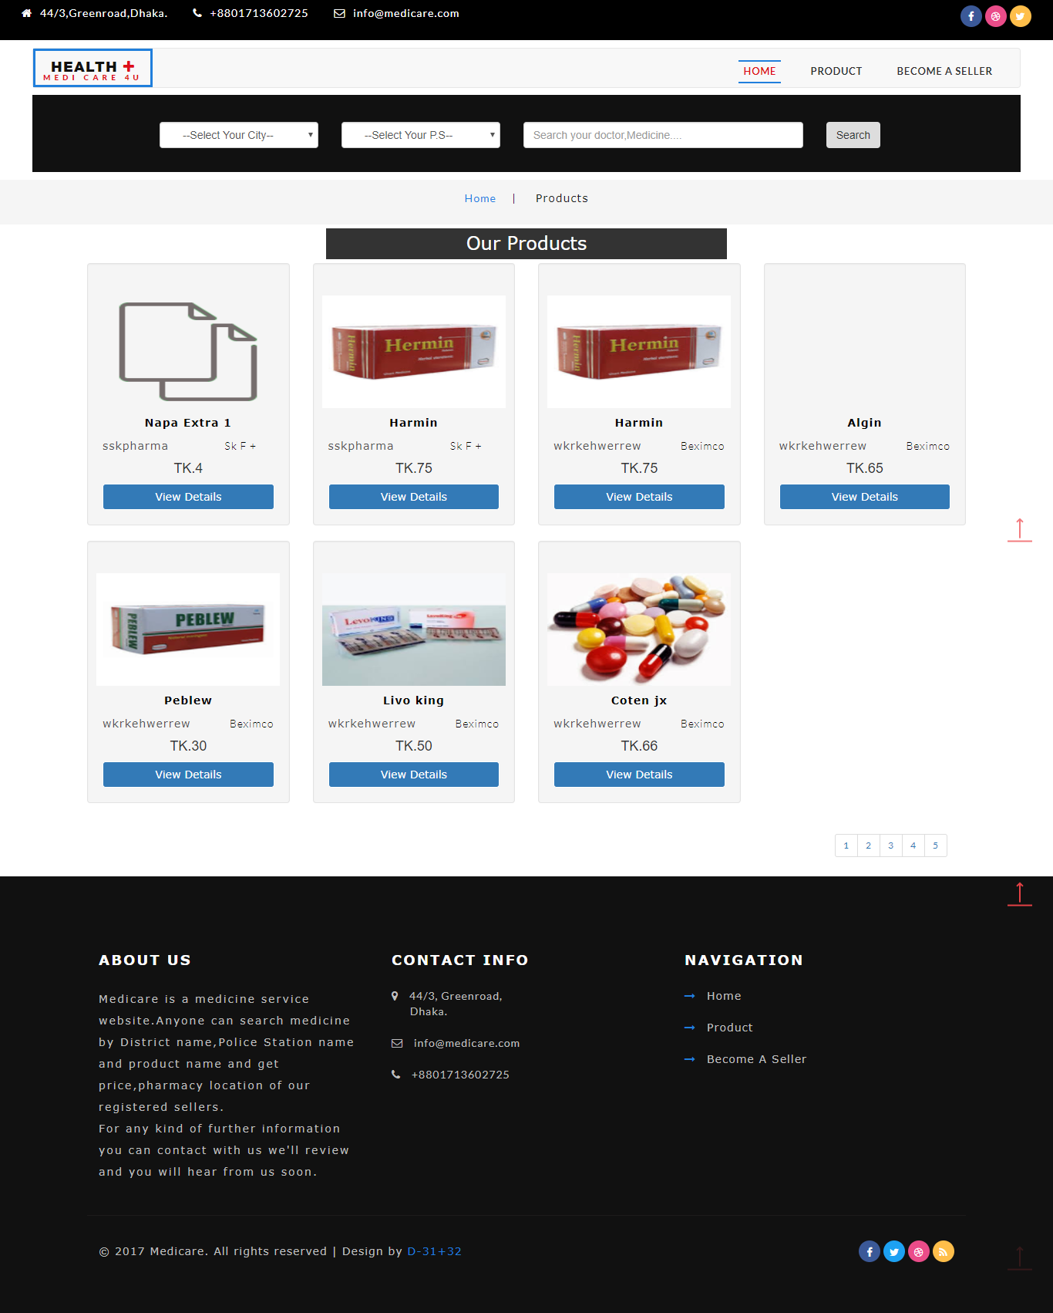

Figure: 6.17 Medicare Product Page

**6.6 Become A Seller**

This page is designed to send seller request. Users, in other words shop owners who wants to use the systems service, will send request through this page. When anyone click this page, it will show the registration form. The registration form requires name, email, cell num, shop name, district selection, police station selection and also a box to leave message to admin.

An email only can be used once. When the request sent it will show that, the request sent and will response in next 72 hours. Then the server automatically response, send a auto generated password to the request email. Then seller can reset the password.

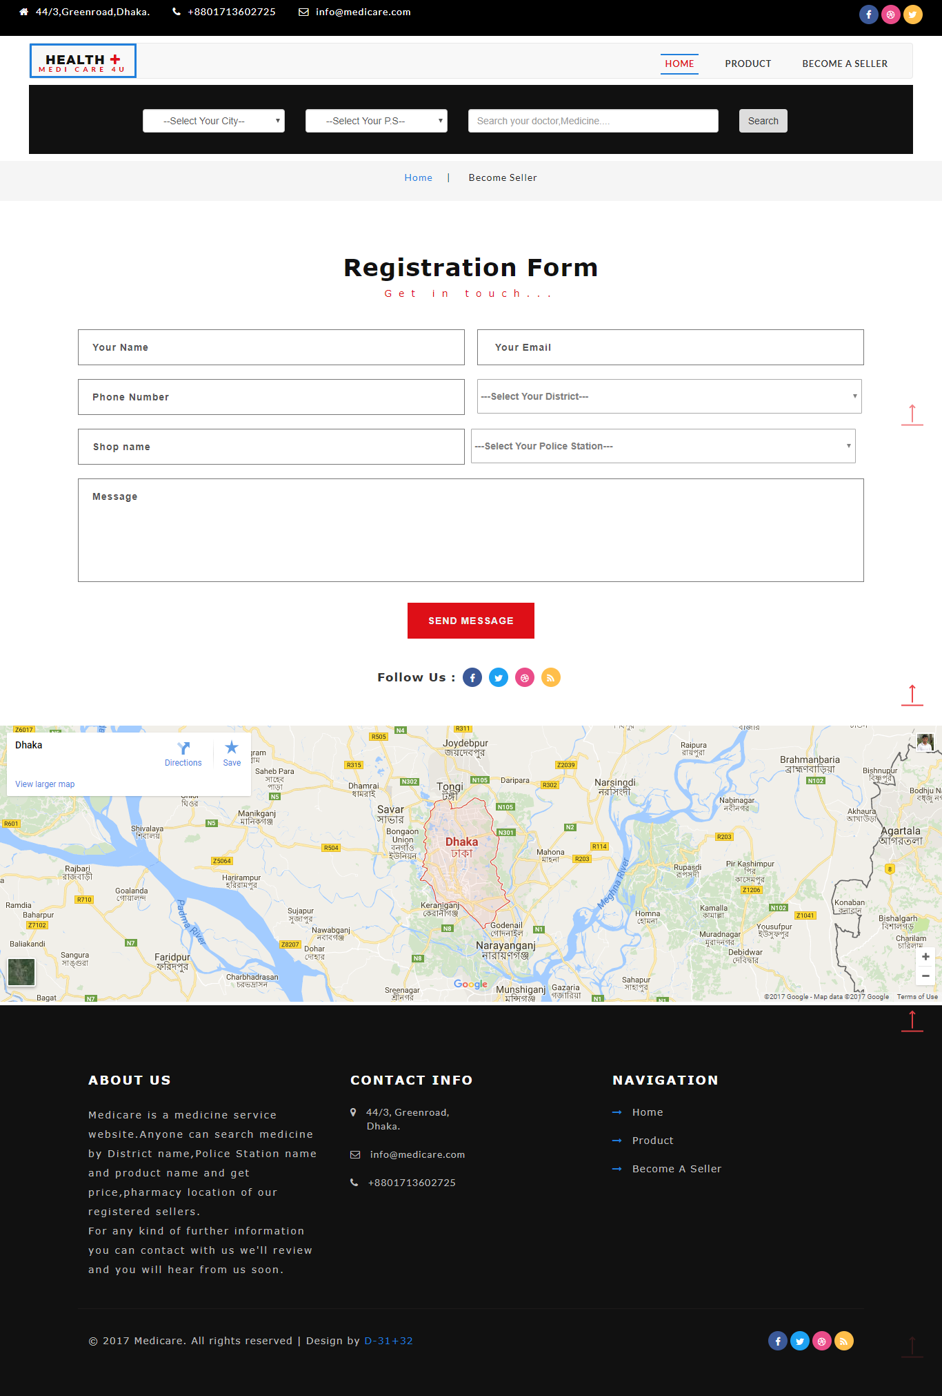

Figure: 6.18 Become A Seller